The Heilmeier Catechism
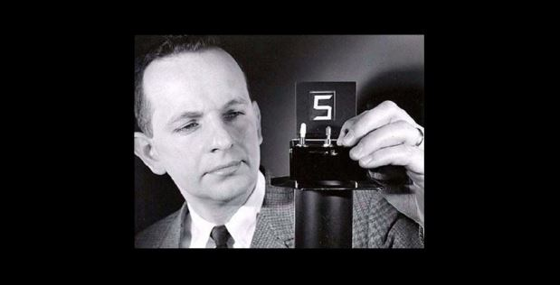

Defense Advanced Research Projects Agency

DARPA operates on the principle that generating big rewards requires taking big risks. But how does the Agency determine what risks are worth taking?
George H. Heilmeier, a former DARPA director (1975-1977), crafted a set of questions known as the "Heilmeier Catechism" to help Agency officials think through and evaluate proposed research programs.

- What are you trying to do? Articulate your objectives using absolutely no jargon.
- How is it done today, and what are the limits of current practice?
- What is new in your approach and why do you think it will be successful?
- Who cares? If you are successful, what difference will it make?
- What are the risks?
- How much will it cost?
- How long will it take?
- What are the mid-term and final “exams” to check for success?

Steve Smith’s Additional Question to Consider:
- What makes you, your team and/or your University uniquely qualified to address the particular problem?

https://www.darpa.mil/work-with-us/heilmeier-catechism

